**Static:**

Step1: Create an android Project in the same way

Step 2: Create fargment1 using below method.

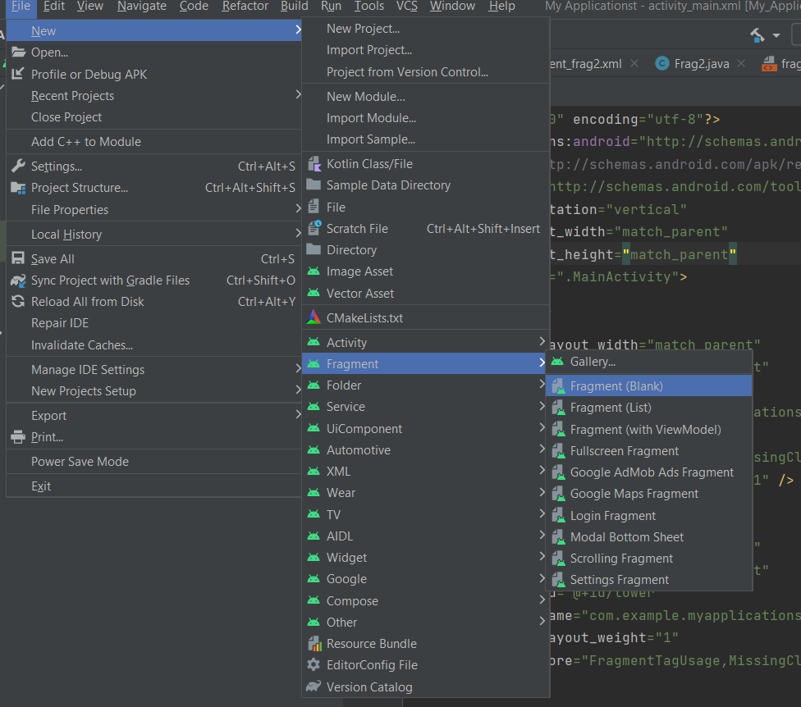

Frag_1.xml code:

<?xml version="1.0" encoding="utf-8"?>  
<FrameLayout xmlns:android="http://schemas.android.com/apk/res/android"  
 xmlns:tools="http://schemas.android.com/tools"  
 android:layout_width="match_parent"  
 android:layout_height="match_parent"  
 android:background="#f8bbd0"  
 android:gravity="center"  
 tools:context=".Fra1">  
  
 <!-- *TODO: Update blank fragment layout* -->  
 <TextView  
 android:layout_width="match_parent"  
 android:layout_height="match_parent"  
 android:text="upper fragment"  
 android:textColor="#e91e63"  
 android:textSize="22sp"  
 android:textStyle="italic|bold"  
 tools:ignore="HardcodedText,TextContrastCheck" />  
  
</FrameLayout>

Frag1.java:

package com.example.myapplicationst;  
  
import android.os.Bundle;  
  
import androidx.fragment.app.Fragment;  
  
import android.view.LayoutInflater;  
import android.view.View;  
import android.view.ViewGroup;  
  
  
public class Fra1 extends Fragment {  
  
 public Fra1() {  
 // Required empty public constructor  
 }  
  
 @Override  
 public View onCreateView(LayoutInflater inflater, ViewGroup container,  
 Bundle savedInstanceState) {  
 // Inflate the layout for this fragment  
 return inflater.inflate(R.layout.*fragment_fra1*, container, false);  
 }  
}

Step 3: Create fargment2 using below method.



Frag_1.xml code:

<?xml version="1.0" encoding="utf-8"?>  
<FrameLayout xmlns:android="http://schemas.android.com/apk/res/android"  
 xmlns:tools="http://schemas.android.com/tools"  
 android:layout_width="match_parent"  
 android:layout_height="match_parent"  
 android:background="#b2ebf2"  
 android:gravity="center"  
 tools:context=".Frag2">  
  
 <!-- *TODO: Update blank fragment layout* -->  
 <TextView  
 tools:ignore="HardcodedText"  
 android:layout_width="match_parent"  
 android:layout_height="match_parent"  
 android:text="lower fragment"  
 android:textSize="22sp"  
 android:textColor="#673AB7"  
 android:textStyle="italic|bold" />  
  
</FrameLayout>

Frag2.java:

package com.example.myapplicationst;  
  
import android.os.Bundle;  
  
import androidx.fragment.app.Fragment;  
  
import android.view.LayoutInflater;  
import android.view.View;  
import android.view.ViewGroup;  
  
public class Frag2 extends Fragment {  
  
 public Frag2() {  
 // Required empty public constructor  
 }  
  
 @Override  
 public View onCreateView(LayoutInflater inflater, ViewGroup container,  
 Bundle savedInstanceState) {  
 // Inflate the layout for this fragment  
 return inflater.inflate(R.layout.*fragment_frag2*, container, false);  
 }

Step 4:

Observe the code in main_xml

<?xml version="1.0" encoding="utf-8"?>  
<LinearLayout xmlns:android="http://schemas.android.com/apk/res/android"  
 xmlns:app="http://schemas.android.com/apk/res-auto"  
 xmlns:tools="http://schemas.android.com/tools"  
 android:orientation="vertical"  
 android:layout_width="match_parent"  
 android:layout_height="match_parent"  
 tools:context=".MainActivity">  
  
 <fragment  
 android:layout_width="match_parent"  
 android:layout_height="wrap_content"  
 android:id="@+id/upper"  
 android:name="com.example.myapplicationst.Fra1"  
 android:layout_weight="1"  
 tools:ignore="FragmentTagUsage,MissingClass"  
 tools:layout="@layout/fragment_fra1" />  
  
 <fragment  
 android:layout_width="match_parent"  
 android:layout_height="wrap_content"  
 android:id="@+id/lower"  
 android:name="com.example.myapplicationst.Frag2"  
 android:layout_weight="1"  
 tools:ignore="FragmentTagUsage,MissingClass" />  
</LinearLayout>

**Android:name: represents the fragment class name which has to be instantiated.**

Output:

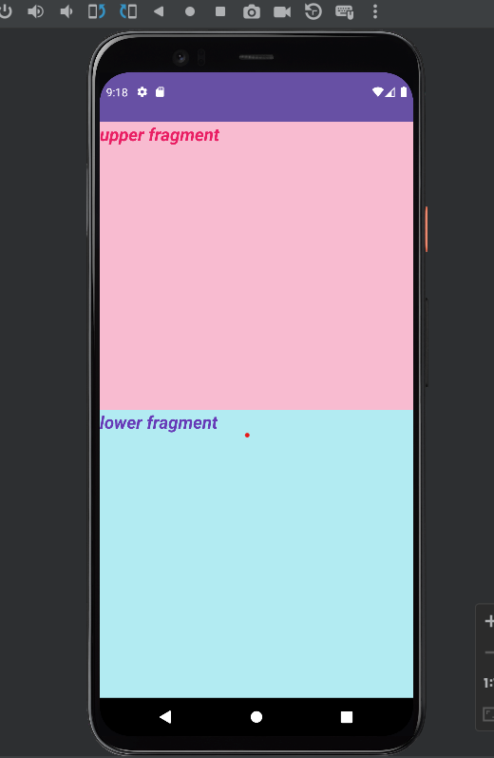

**Dynamic fragments:**

Step1: Create an android Project in the same way

Step 2: Create fargment1 using same above method.

Step 3:

Fragment_1.xml

<?xml version="1.0" encoding="utf-8"?>  
<LinearLayout xmlns:android="http://schemas.android.com/apk/res/android"  
 xmlns:tools="http://schemas.android.com/tools"  
 android:layout_width="match_parent"  
 android:layout_height="match_parent"  
 android:orientation="vertical"  
 tools:context=".fragment1">  
  
 <TextView  
 android:id="@+id/textView3"  
 android:layout_width="match_parent"  
 android:layout_height="53dp"  
 android:text="This is fragment 2"  
  
 android:textColor="@color/design_default_color_primary"  
 android:textSize="25sp"  
 android:textStyle="bold" />  
  
 <TextView  
 android:id="@+id/textView4"  
 android:layout_width="match_parent"  
 android:layout_height="53dp"  
 android:text="Fragment 2"  
 android:textColor="@color/design_default_color_error"  
 android:textSize="25sp"  
 android:textStyle="bold" />  
</LinearLayout>

Fragment_1.java:

package com.example.myapplicationfra;  
  
import android.os.Bundle;  
  
import androidx.fragment.app.Fragment;  
  
import android.view.LayoutInflater;  
import android.view.View;  
import android.view.ViewGroup;  
  
  
public class fragment1 extends Fragment {  
  
  
 @Override  
 public View onCreateView(LayoutInflater inflater, ViewGroup container,  
 Bundle savedInstanceState) {  
 // Inflate the layout for this fragment  
 return inflater.inflate(R.layout.*fragment_fragment1*, container, false);  
 }  
}

fragment_2.xml:

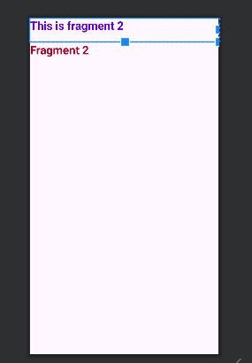

**No change in fragment2.java file same as fragment_1.java file**

Step4:

**Activity_main.xml:**

<?xml version="1.0" encoding="utf-8"?>  
<RelativeLayout xmlns:android="http://schemas.android.com/apk/res/android"  
  
 xmlns:tools="http://schemas.android.com/tools"  
 android:layout_width="match_parent"  
 android:layout_height="match_parent"  
 tools:context=".MainActivity">  
  
 <Button  
 android:id="@+id/button1"  
 android:layout_width="142dp"  
 android:layout_height="wrap_content"  
 android:layout_alignParentStart="true"  
 android:layout_alignParentTop="true"  
 android:layout_alignParentEnd="true"  
 android:layout_alignParentBottom="true"  
 android:layout_marginStart="60dp"  
 android:layout_marginTop="43dp"  
 android:layout_marginEnd="209dp"  
 android:layout_marginBottom="633dp"  
 android:text="Fragment1"  
 tools:ignore="HardcodedText" />  
  
 <Button  
 android:id="@+id/button2"  
 android:layout_width="161dp"  
 android:layout_height="68dp"  
 android:layout_alignParentEnd="true"  
 android:layout_alignParentBottom="true"  
 android:layout_marginEnd="189dp"  
 android:layout_marginBottom="527dp"  
 android:text="Fragment2"  
 tools:ignore="HardcodedText" />  
  
 <FrameLayout  
 android:layout_width="match_parent"  
 android:layout_height="match_parent"  
 android:id="@+id/fl_fragment"  
 android:layout_below="@+id/button2">  
  
 </FrameLayout>  
</RelativeLayout>

**MainActivity.java:**

package com.example.myapplicationfra;  
  
import androidx.appcompat.app.AppCompatActivity;  
import androidx.fragment.app.Fragment;  
import androidx.fragment.app.FragmentManager;  
import androidx.fragment.app.FragmentTransaction;  
  
import android.annotation.SuppressLint;  
import android.os.Bundle;  
import android.view.View;  
import android.widget.Button;  
  
public class MainActivity extends AppCompatActivity {  
 Button buttonfrag, buttonfragg;  
  
 @Override  
 protected void onCreate(Bundle savedInstanceState) {  
 super.onCreate(savedInstanceState);  
 setContentView(R.layout.*activity_main*);  
 buttonfrag = findViewById(R.id.*button1*);  
 buttonfragg = findViewById(R.id.*button2*);  
 buttonfrag.setOnClickListener(new View.OnClickListener() {  
 @Override  
 public void onClick(View v) {  
 replaceFragment(new fragment1());  
 }  
 });  
 buttonfragg.setOnClickListener(new View.OnClickListener() {  
 @Override  
 public void onClick(View v) {  
 replaceFragment(new fragment2());  
 }  
 });  
 }  
  
 private void replaceFragment(Fragment fragment) {  
 FragmentManager fragmentManager = getSupportFragmentManager();  
 FragmentTransaction fragmentTransaction = fragmentManager.beginTransaction();  
 fragmentTransaction.replace(R.id.*fl_fragment*, fragment);  
 fragmentTransaction.commit();  
 }  
  
}

Output:

